Chosen System: Sequential Automatic Transmission, with states P, R, N, D.

FSM:

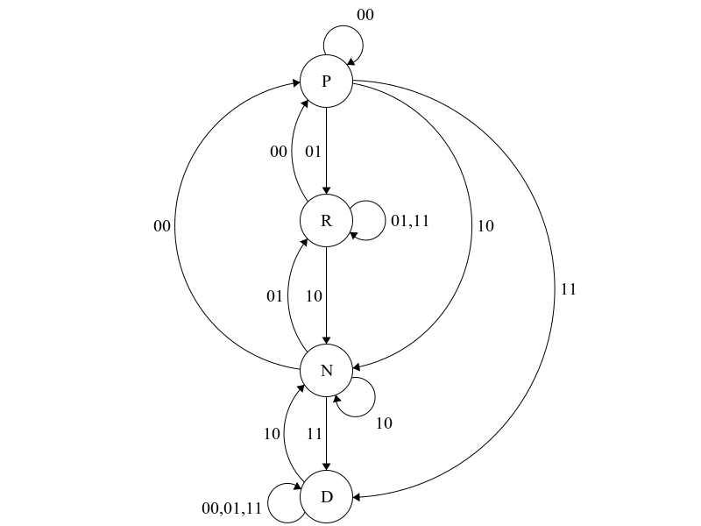

In this FSM diagram, it shows four states P, R, N, D. [Park, Reverse, Neutral, Drive]

In this automatic transmission FSM, the binary assignments are as below:

00: P

01: R

10: N

11: D

When state is in P, it has four possible outcomes if given an input, the outcomes after the input can be: Stay in P, Change to R, Change to N, Change to D.

When state is in R, it also has three possible outcomes if given an input, the outcome after the input can be: Change to P, Stay in R, Change to N. The R state cannot go to D directly and will stay in R if given the input for D (11)

When State is in N, it has four possible outcomes if given an input, the outcomes after the input can be: Change to P, Change to R, Stay in N, Change to D.

When State in D, it has only two possible outcomes if given an input, the outcomes after the input can be: Change to N, Stay in D. D is not able to directly change states to R or P and will stay in D if given the inputs for R or P (01 or 00).

Here below is the State and Transition Table for the automatic transmission FSM:

|  |  |  |  |  |
| --- | --- | --- | --- | --- |
| Min Terms | Current State | Input | Next State | Output |
|  |  |  |  |  |
|  | [A B] | [C D] |  | Y1 Y2 |
| M0 | 0 0 | 0 0 | 0 0 | 0 0 |
| M1 | 0 0 | 0 1 | 0 1 | 0 1 |
| M2 | 0 0 | 1 0 | 1 0 | 1 0 |
| M3 | 0 0 | 1 1 | 1 1 | 1 1 |
|  |  |  |  |  |
| M4 | 0 1 | 0 0 | 0 0 | 0 0 |
| M5 | 0 1 | 0 1 | 0 1 | 0 1 |
| M6 | 0 1 | 1 0 | 1 0 | 1 0 |
| M7 | 0 1 | 1 1 | 0 1 | 0 1 |
|  |  |  |  |  |
| M8 | 1 0 | 0 0 | 0 0 | 0 0 |
| M9 | 1 0 | 0 1 | 0 1 | 0 1 |
| M10 | 1 0 | 1 0 | 1 0 | 1 0 |
| M11 | 1 0 | 1 1 | 1 1 | 1 1 |
|  |  |  |  |  |
| M12 | 1 1 | 0 0 | 1 1 | 1 1 |
| M13 | 1 1 | 0 1 | 1 1 | 1 1 |
| M14 | 1 1 | 1 0 | 1 0 | 1 0 |
| M15 | 1 1 | 1 1 | 1 1 | 1 1 |

K-Map For Y1:



|  |  |  |  |  |
| --- | --- | --- | --- | --- |
|  | C’.D’ | C’.D | C.D | C.D’ |
| A’.B’ | 0 | 0 | 1 | 1 |
| A’.B | 0 | 0 | 0 | 1 |
| A.B | 1 | 1 | 1 | 1 |
| A.B’ | 0 | 0 | 1 | 1 |

Derived combinatorial boolean equation for Y1 = B'C + CD' + AB

K-Map For Y2:

|  |  |  |  |  |
| --- | --- | --- | --- | --- |
|  | C’.D’ | C’.D | C.D | C.D’ |
| A’.B’ | 0 | 1 | 1 | 0 |
| A’.B | 0 | 1 | 1 | 0 |
| A.B | 1 | 1 | 1 | 0 |
| A.B’ | 0 | 1 | 1 | 0 |

Derived combinatorial boolean equation for Y2 = D + ABC'

Now we can say that:

Output Y1 = B'C + CD' + AB

Output Y2 = D + ABC'